**Connect your CPQ developer org to trailhead and AppExchange** –

1. Login to <https://trailhead.salesforce.com/users/profiles/orgs> and connect your CPQ org there By clicking on **Connect Org** button   
   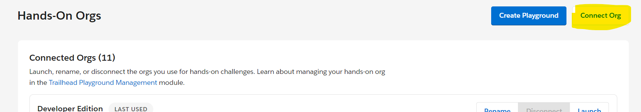
2. Login to developer org and it will get connected.
3. Go to <https://www.salesforce.com/trailblazer/settings> and click on the Add Account button   
   Select Salesforce and login to your developer CPQ org.

**Steps to install Adobe Acrobat Sign eSignatures for Salesforce and Adobe Acrobat Sign for Salesforce CPQ**

Steps to install Adobe Acrobat Sign eSignatures for Salesforce

1. Needs to install Go to the link - <https://appexchange.salesforce.com/appxListingDetail?listingId=a0N300000016ZmCEAU&cta=gin>
   1. 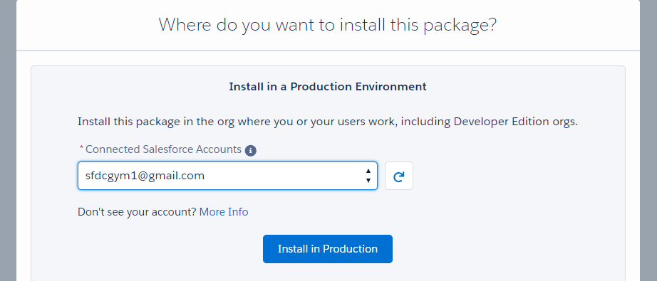
   2. Select the account and click on **Install in Production** button
   3. Select Install for Admins and click on Install button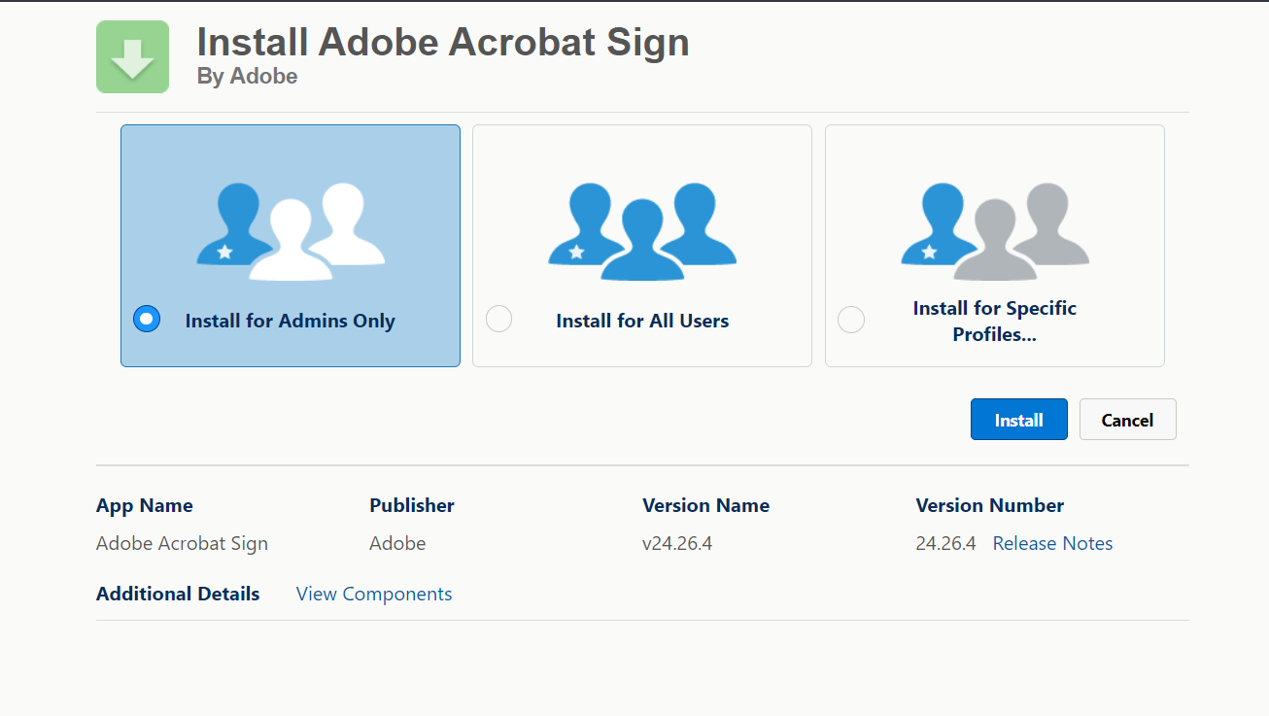
2. Also needs to install **Adobe Acrobat Sign for Salesforce CPQ** package <https://appexchange.salesforce.com/appxListingDetail?listingId=a0N3A00000EJmhXUAT&cta=gin>
   1. Follow the same steps as given in the above step to install this package as well

**Setup Salesforce org and Adobe Integration Steps –**

1. **Assign Adobe Acrobat Sign Admin to the user:**

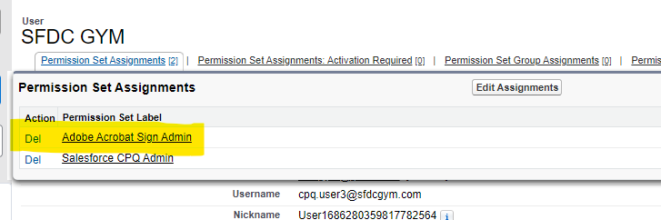

1. **Link Adobe sign and salesforce account:**
   1. Go to App manager and search **Adobe Acrobat Sign for Salesforce** and open that
   2. Click on **Adobe Acrobat Sign Admin** Tab  
      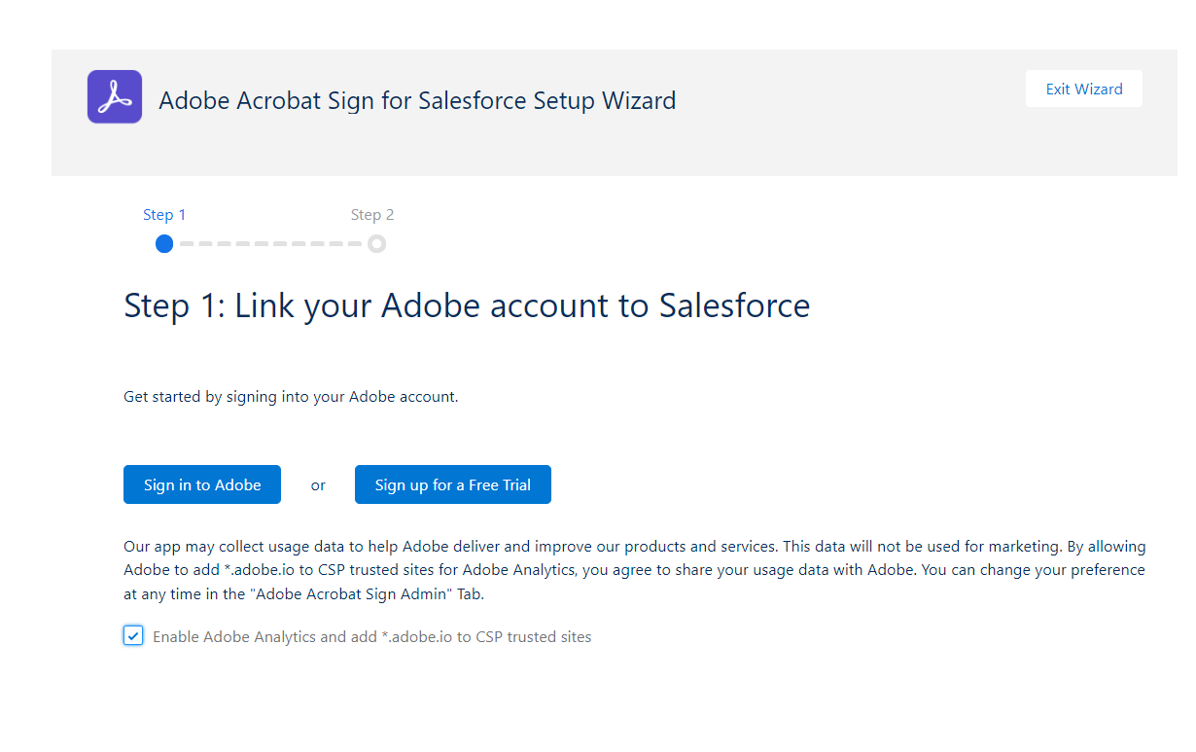
   3. Click on Sign in to Adobe if you already have a account or click on Sign up for a Free Trial button and create a account on Adobe
   4. Go to remote site settings and add this URL  
      <https://api.na1.adobesign.com/oauth/v2/token>  
      <https://api.in1.echosign.com/api/rest/v5/users/me>
   5. After couple of tries you will get a successful message screen - 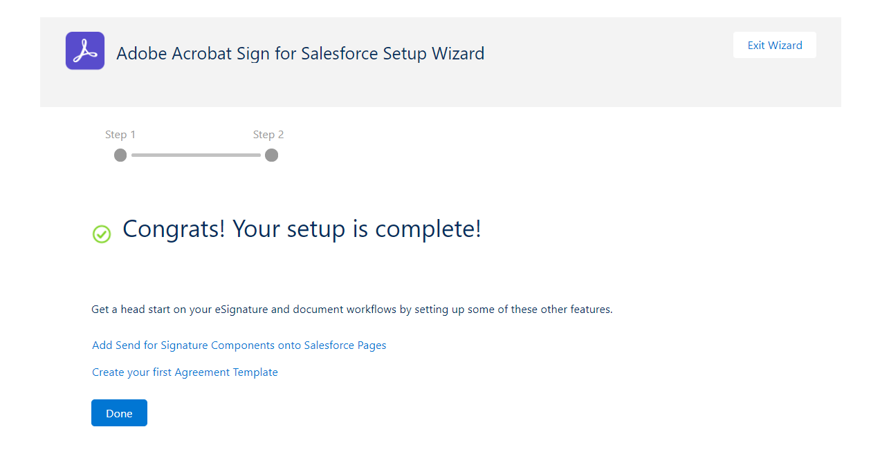
2. **Configure Quote Document object for sending agreements:**
   1. Go to Object Manager
   2. Search for Quote Document and click on Page Layout
   3. Go to Quote Document Layout and click on related tab
   4. Add Agreements related tab and save it.  
      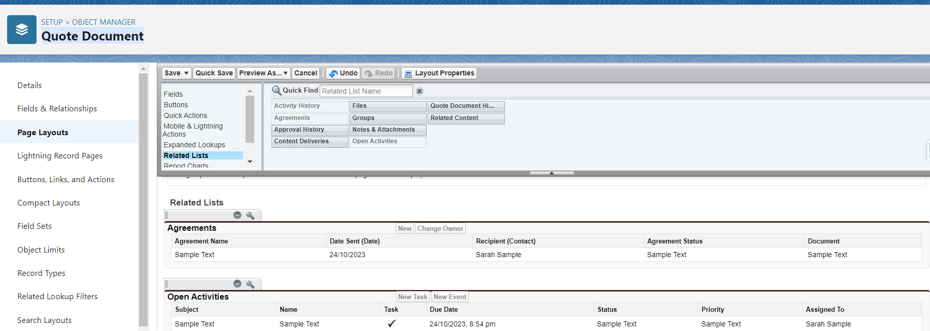
3. **Configure Opportunity and Account object for sending agreements**
   1. Similar to Quote Object, Add Agreements tab for Opportunity (edit **CPQ Opportunity Layout**) and Account (edit **CPQ Account Layout**)
4. **Add the Agreement Template to the Quote Template**
   1. Go to Object Manger and search for Quote Template object.
   2. Edit the Quote Template layout and add Agreement Template field  
      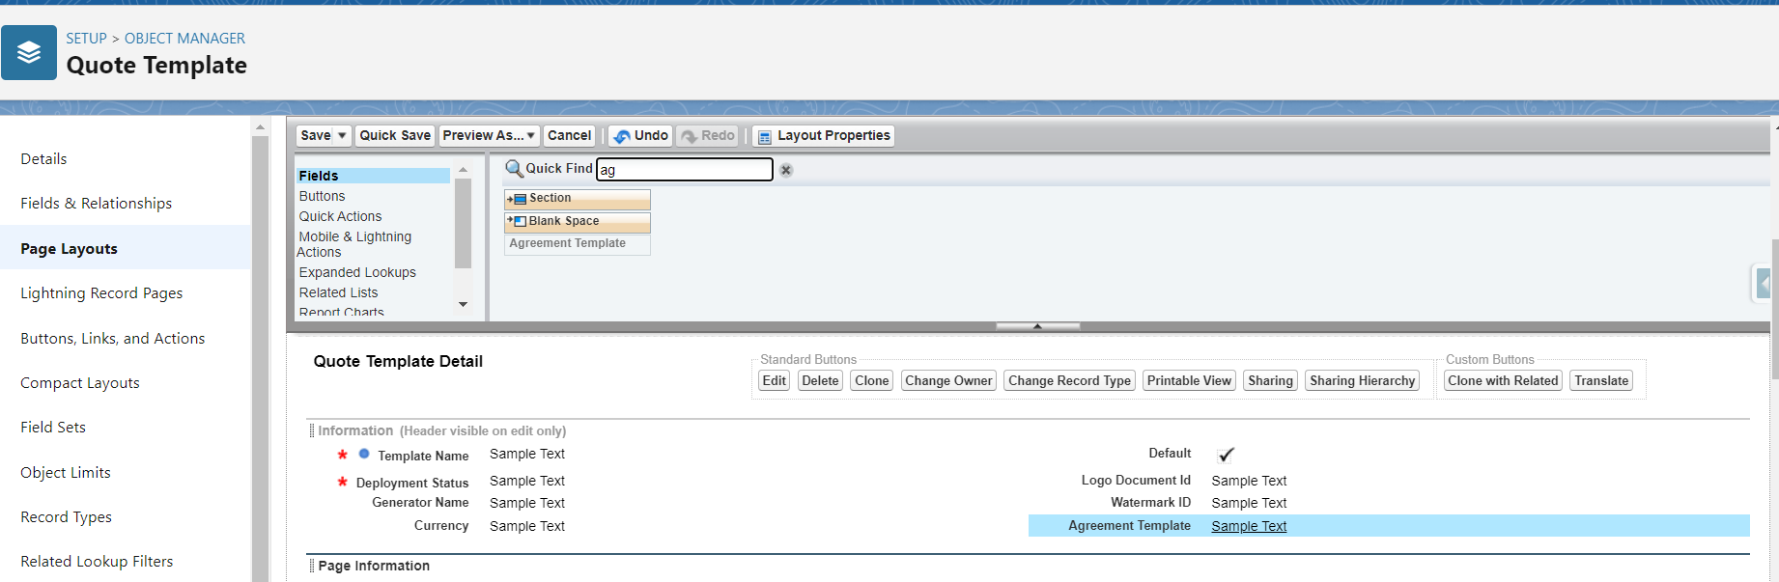
5. **Add Package Apex Class to Plugins**
   1. Go to Setup and search for Installed Packages
   2. Click on Configure button next to Salesforce CPQ
   3. Go to Plugin tab and under Electronic Signature Plugin Add this apex class- ASSFCPQ.AdobeSignElectronicSignaturePlugin  
      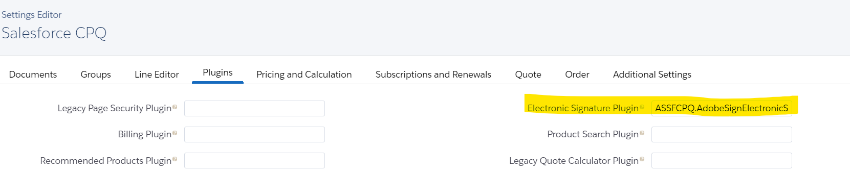
6. **Create Default Templates**
   1. Go to Adobe Acrobat Sign for Salesforce App and Click on Agreement Template tab. Click on New button
   2. On Template Details tab click on Map data into aggrement fields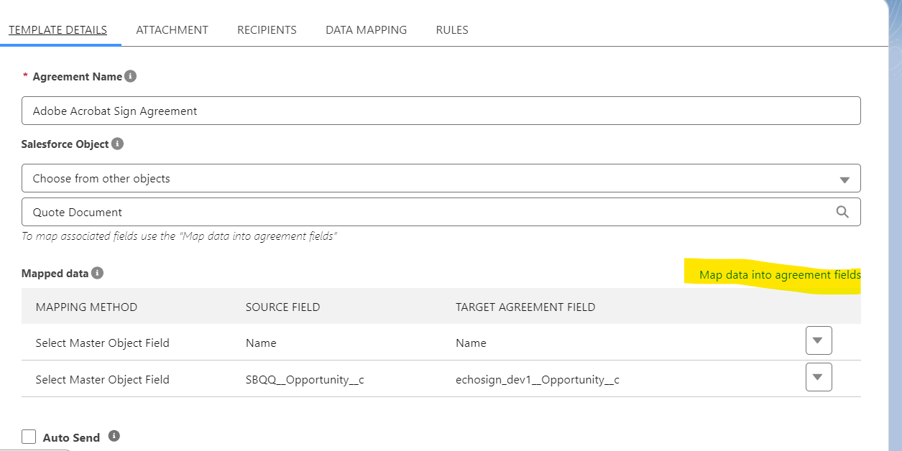
   3. Check Select from Object and add Name and Name in both drop down. Save the changes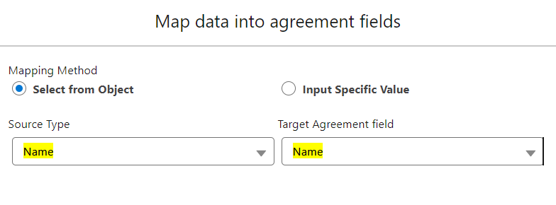
   4. Go to the Attachment tab and click on **Choose Document Source** link under Advanced Options. Select Runtime Variable and Gave QuoteDocument under Add a runtime variable name-

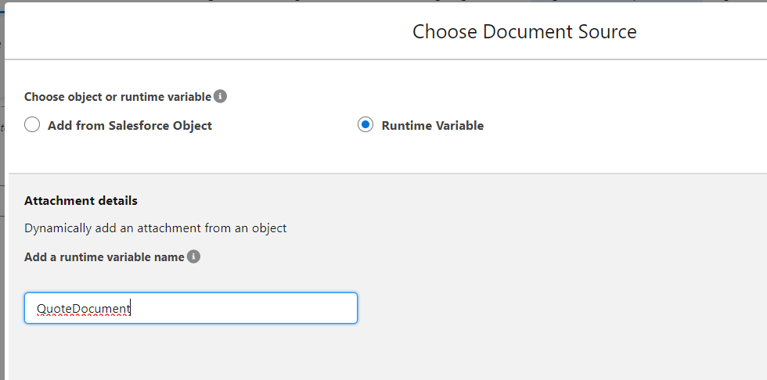

* 1. Go to the Recipients tab and Click on Add Fixed Recipient button. Select the contact from the dropdown and save the changes. Here make sure you have added a valid email to the contact. Quote Document will be send to this email only.  
     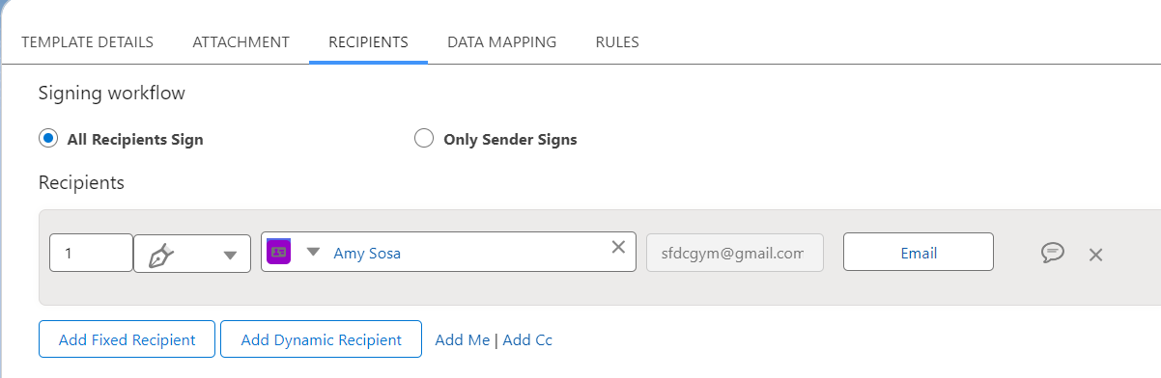
  2. GO to the Rules tab and select **Set as default template for all agreements** checkbox save the changes.

1. **Add Agreement template to Quote Template**
   1. Go to the Salesforce CPQ Application and select Quote Template
   2. Select the existing Quote Template and edit it.
   3. Under **Agreement Template** field add the new template that we have created in the above steps.  
      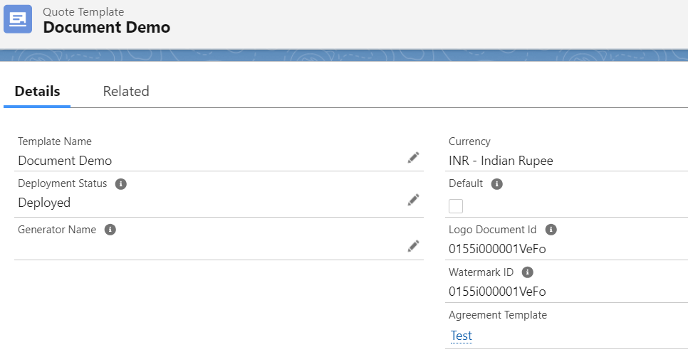
2. **Generate and send an agreement with an automatic quote Document Attachment**
   1. Create a New Account
   2. Line the same contact that we have added to Agreement Template (Please check 7.e point) to the Account
   3. Create a new Opportunity and link that to Account
   4. From Opportunity Create a new Quote and Add some products
   5. Click on Generate Document button to the Quote and now you will see an new button - 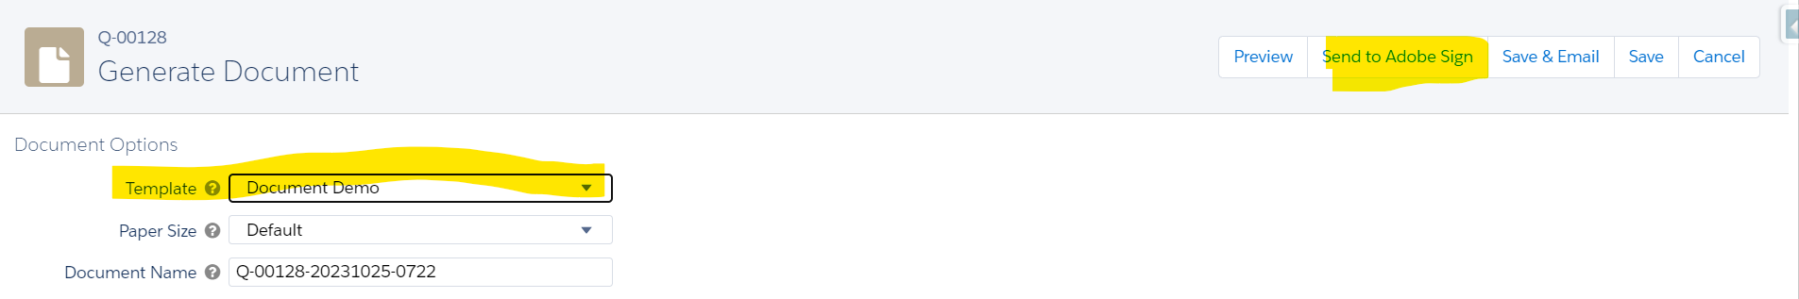
   6. Click on Send to Adobe Sign. It will redirect to Quote Document Page. Click on the Related Tab and Select the Agreement 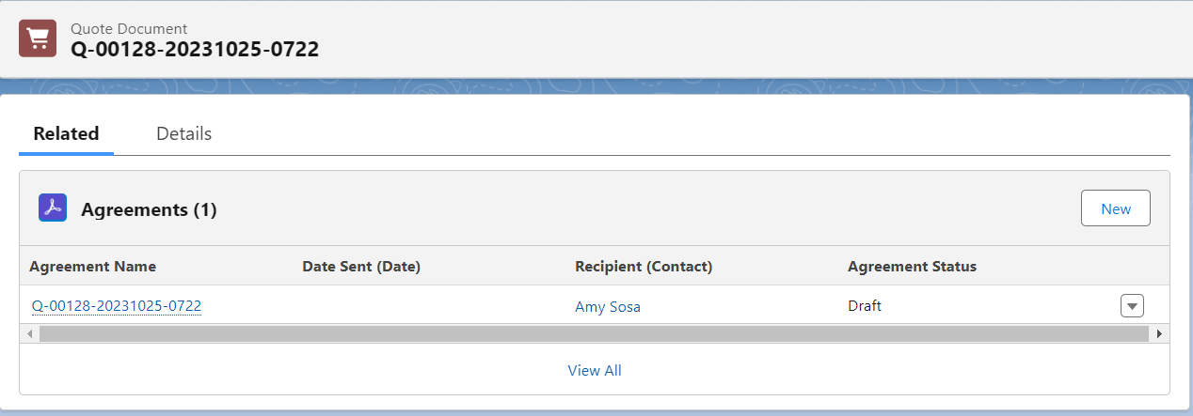
   7. Click on **Preview & Add Signature Fields** Checkbox and click on next button -  
      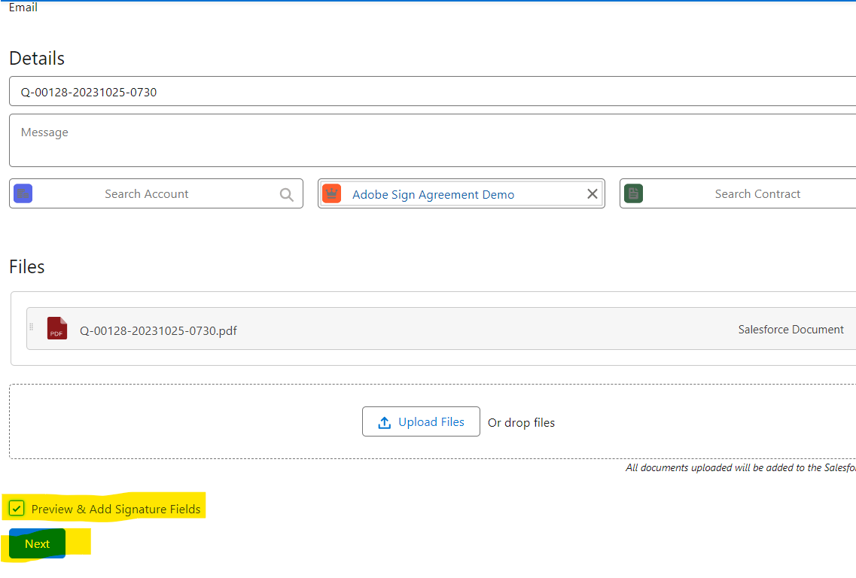
   8. Once Clicked it will redirect you to a new tab.( Make sure you allow to your browser to open window in new tab)
   9. Scroll down to the footer of the document and from right side drag Signature to the left side signature space -   
      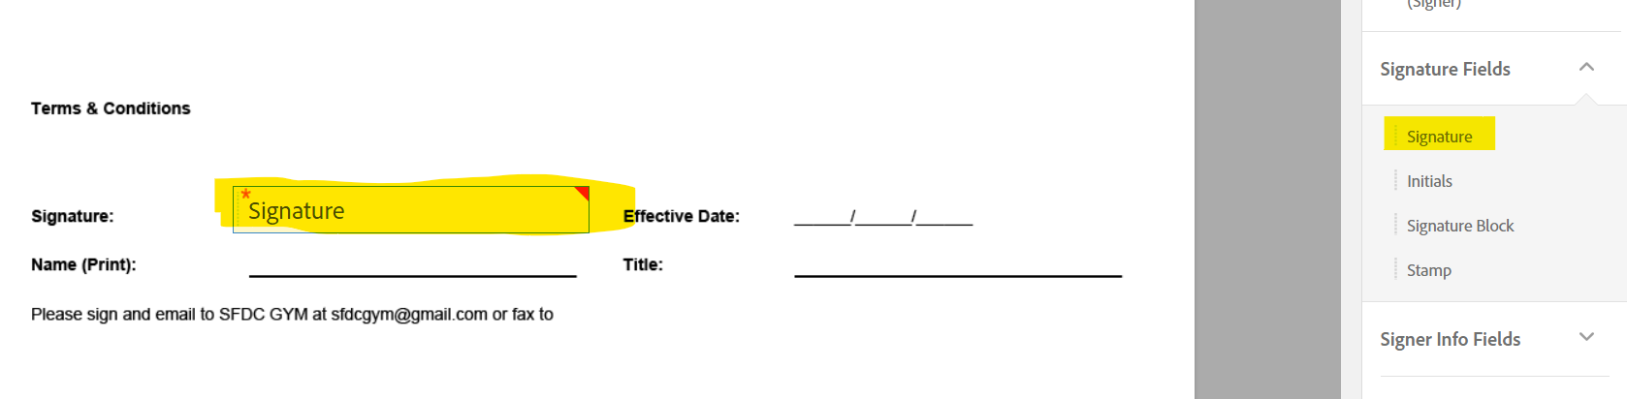
   10. Similarly select from right side click on Date fields and drag Text Input and from signer info Field section Drag Name and Title as well. Finally click on Sign then Send button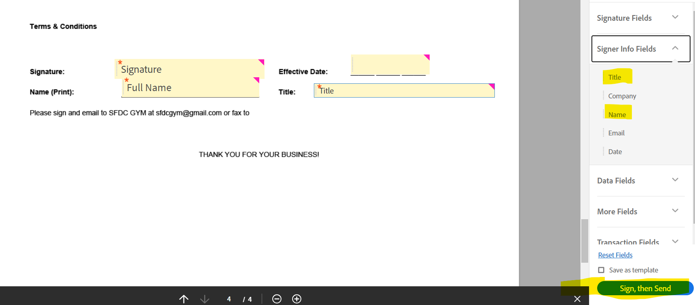
   11. Check the email that you have added to the contact. You will notice you get 2 emails - 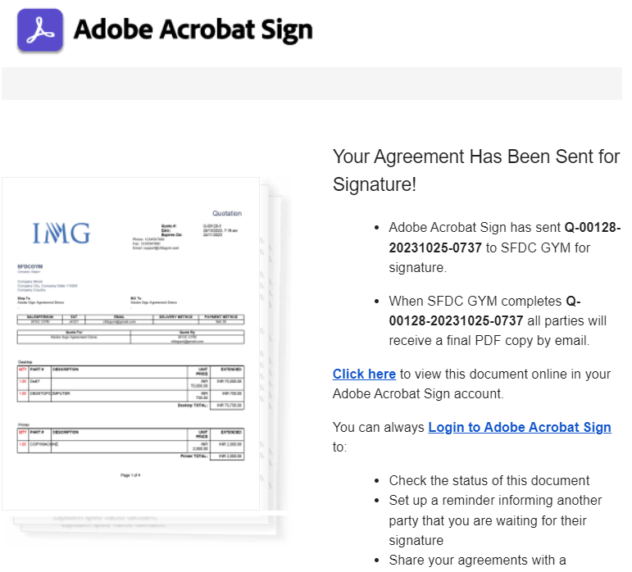  
       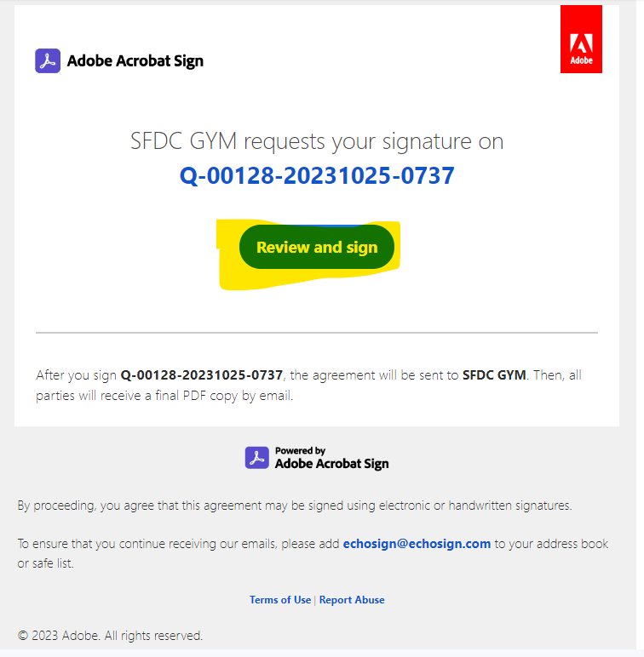
   12. Click on Review and sign button. Once Clicked update the signature and dates. And click on Sign button
   13. You will see a successful message window. You can close it
   14. Now refresh the Agreement in salesforce and you will see the status is changed to Signed and at Agreement Event the logs will get populated.

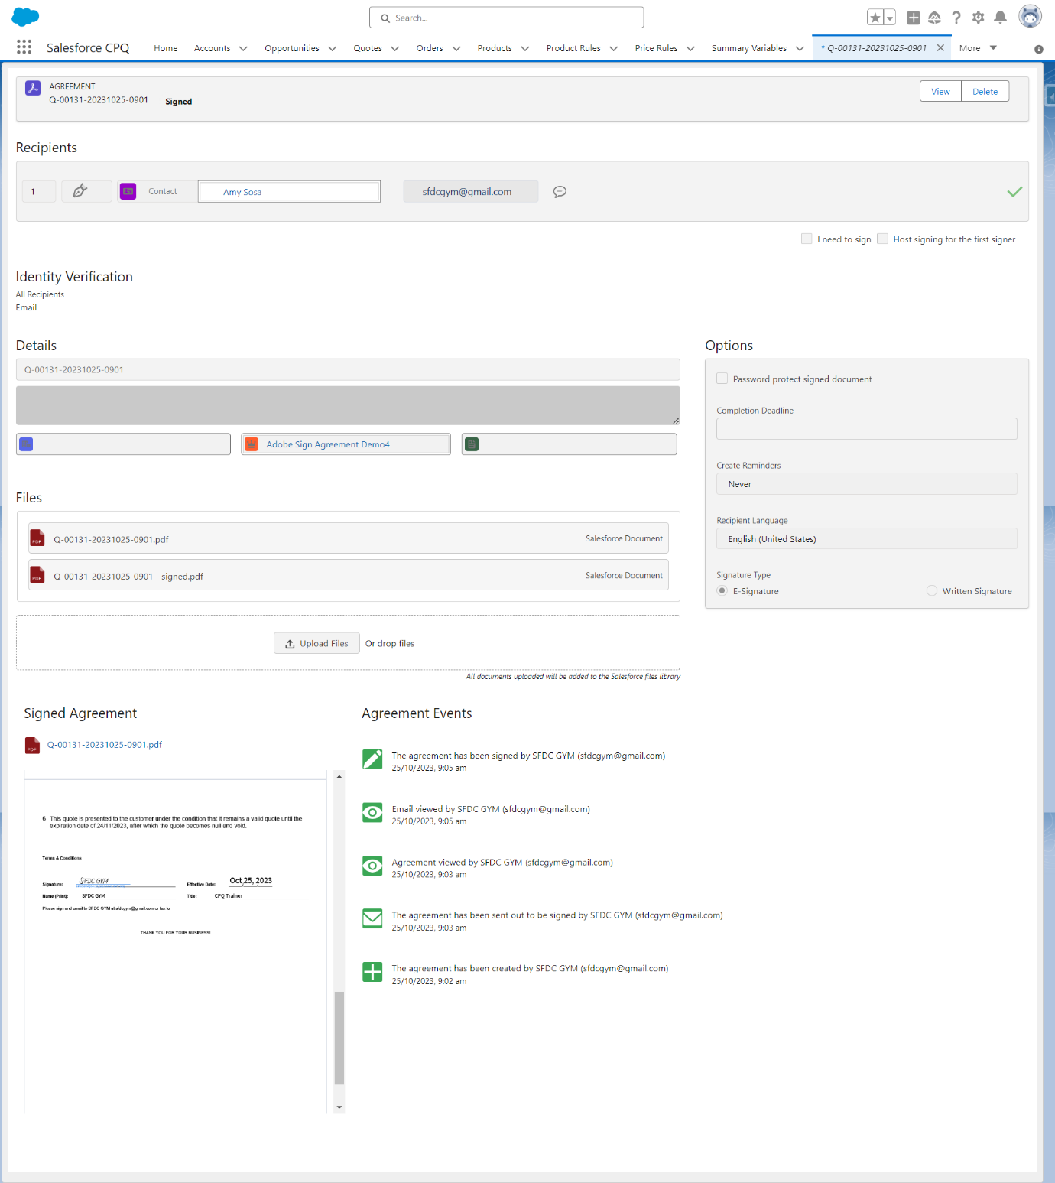

**Adobe Acrobat Sign for Salesforce: Troubleshooting Guide**

<https://helpx.adobe.com/sign/integrations/salesforce-troubleshooting-guide.html>